**ASSIGNMENT – 11  
PROBLEM STATEMENT -Build scaling plans in AWS that balances the load on different EC2 instances.**STEP 1- From AWS home screen, select EC2 option.

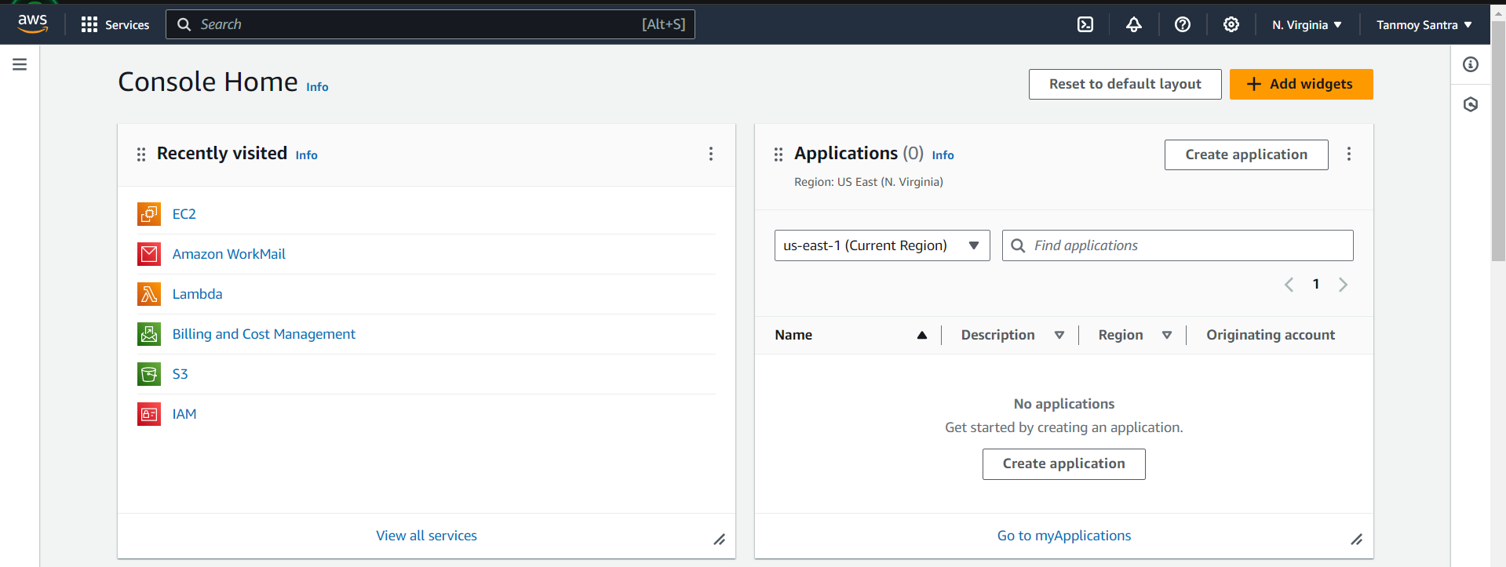

STEP 2- Under the Launch Templates, click on Create Launch Template  
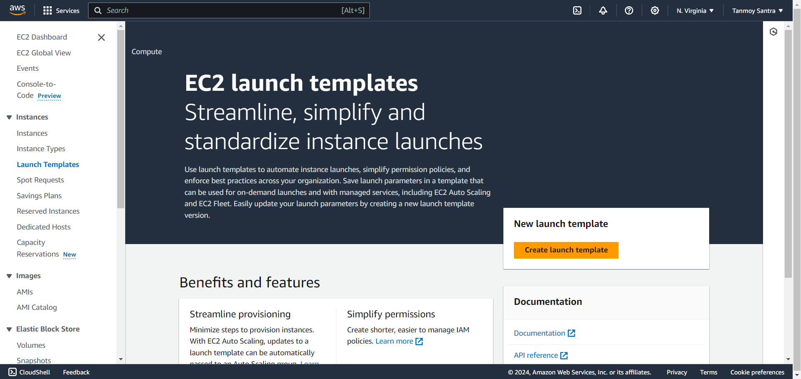  
STEP 3- Give a name and description to the template. Check the Auto Scaling Guidance checkbox.  
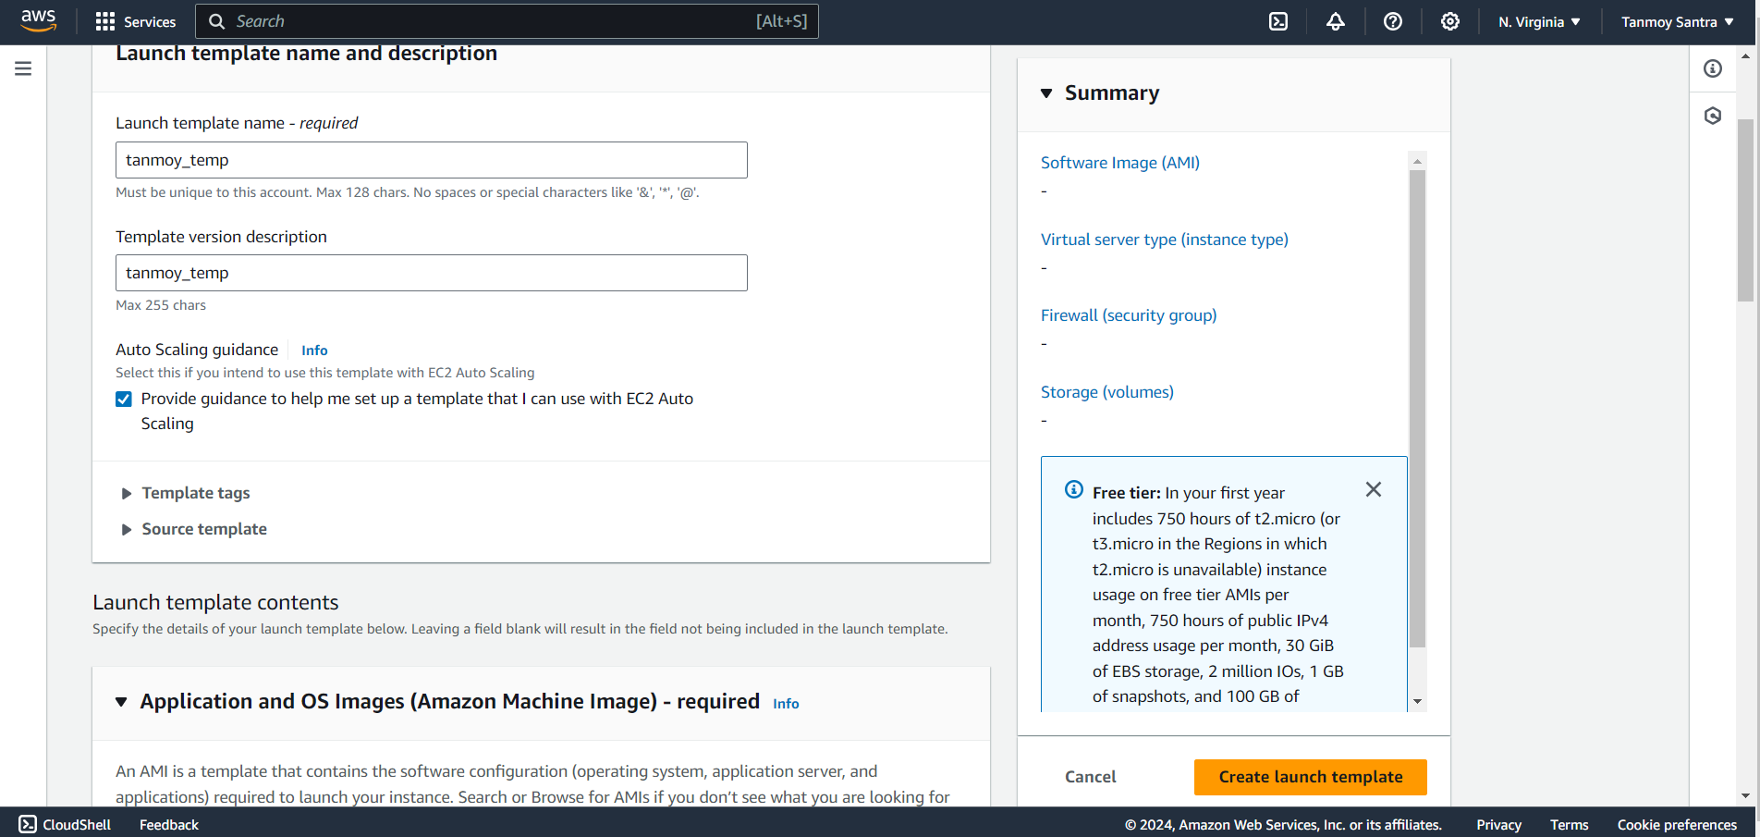

STEP 4- Select Ubuntu & under instance type, select t2.micro .

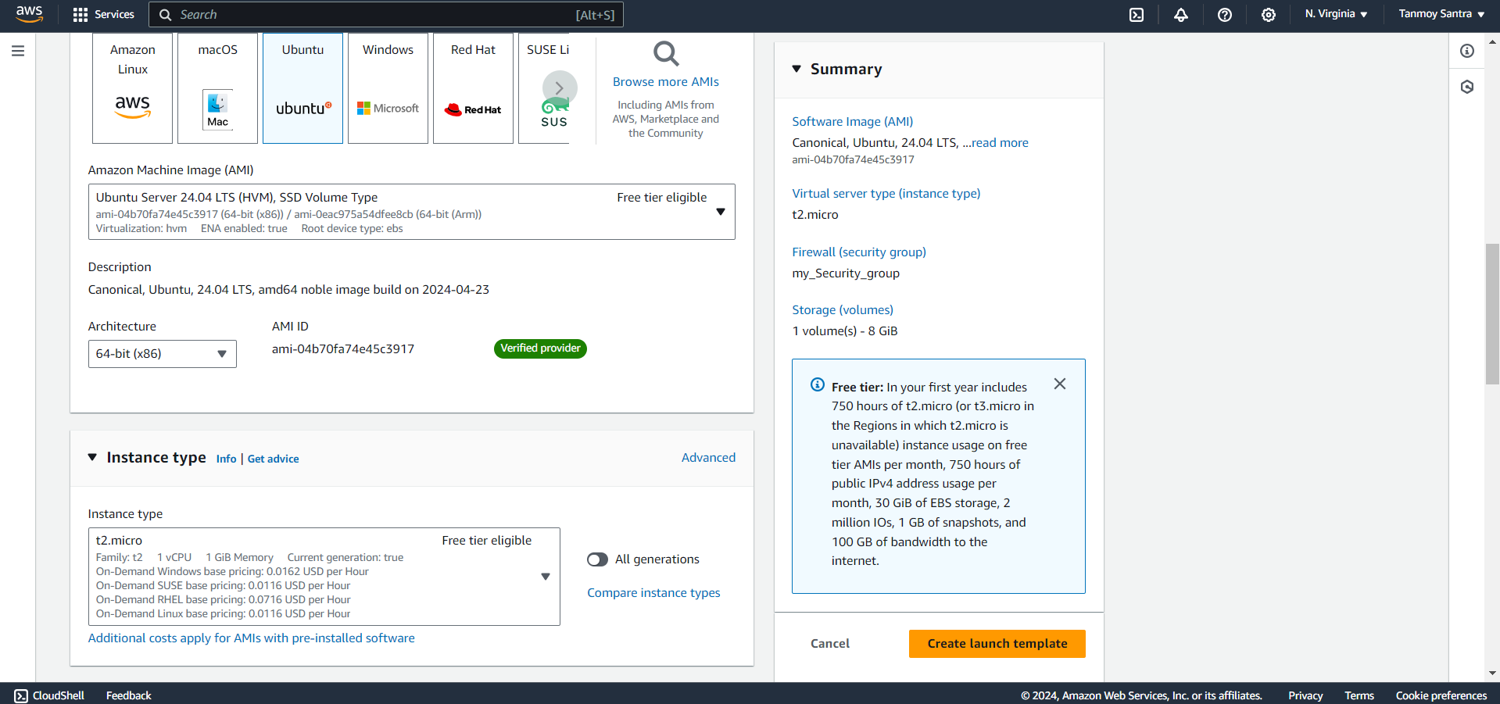

STEP 5- Under key pair, select an existing key and select the user created Security group.

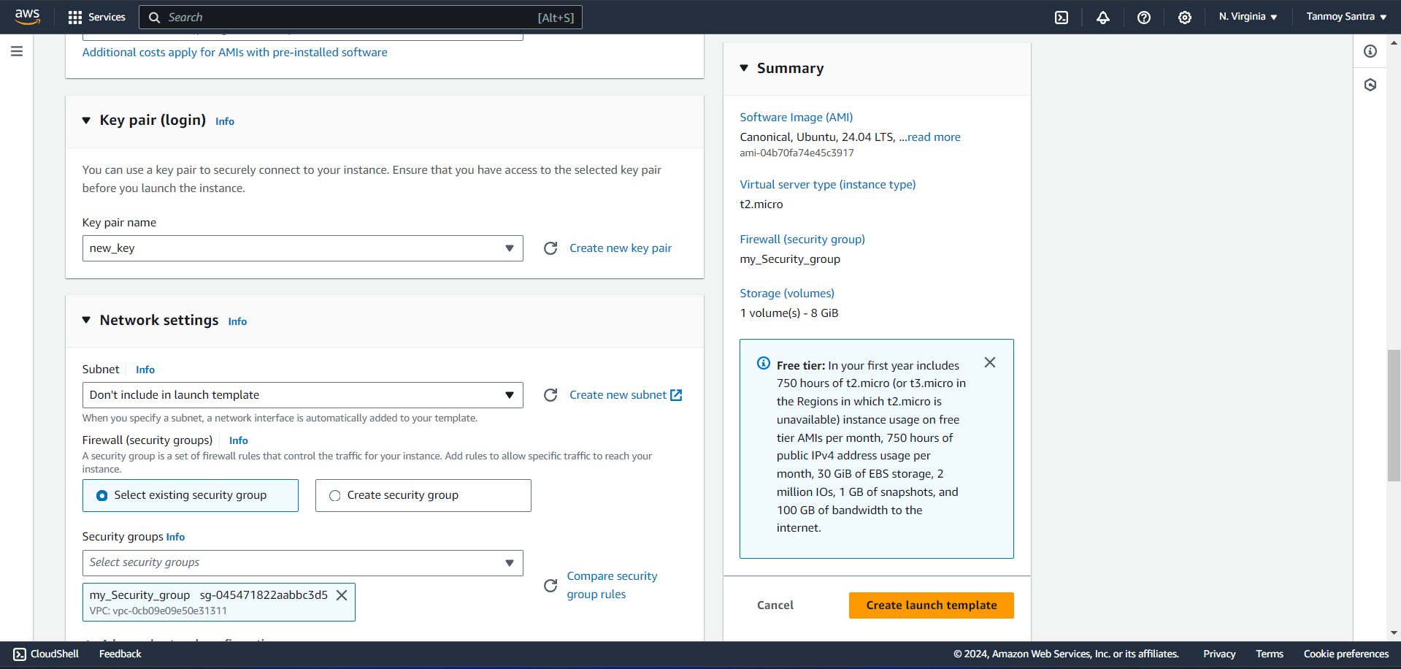

STEP 6- Expand the Advanced Details tab.  
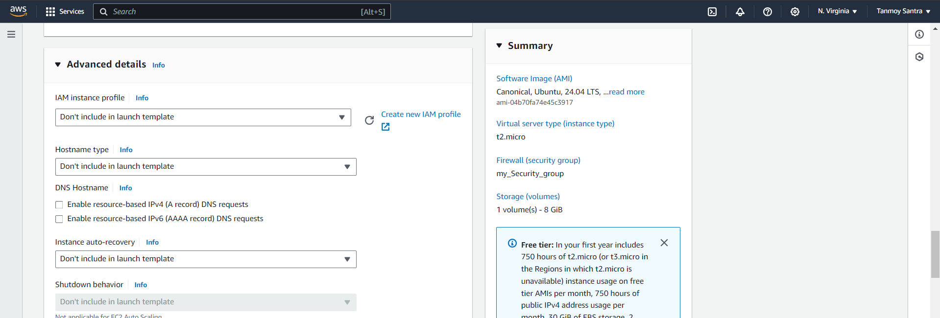

STEP 7- Scroll down to the bottom, in the bash console type the following commands:Then click on Create Launch Template .  
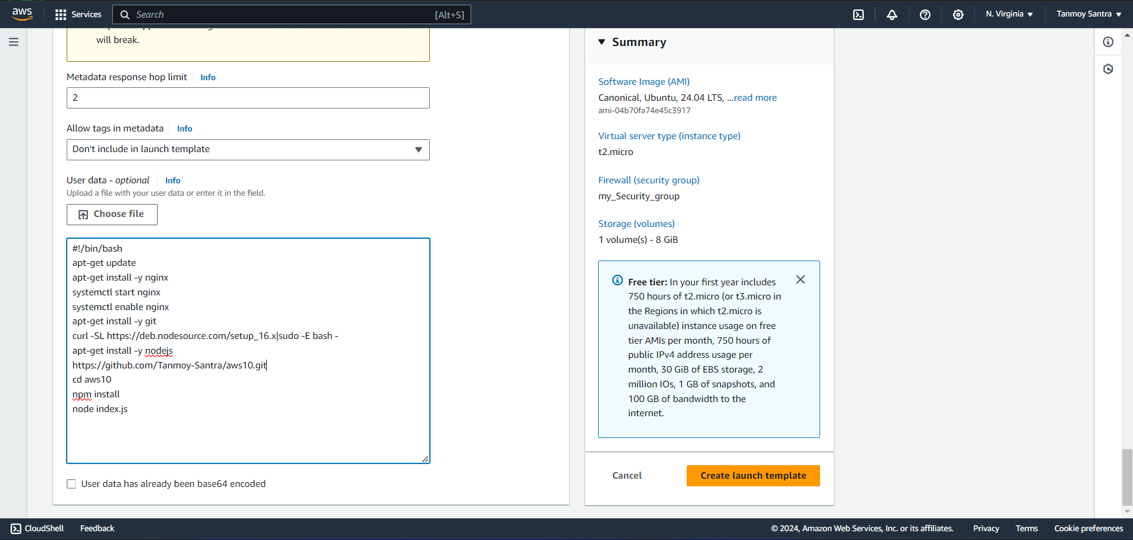  
STEP 8-Click on Auto Scaling Group .  
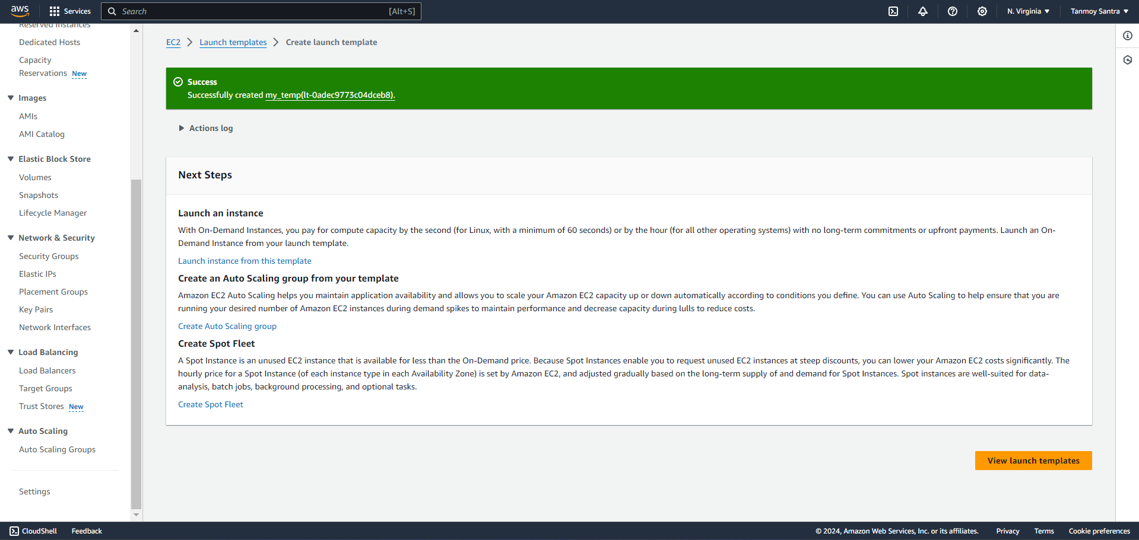  
STEP 9- Click on Create Auto Scaling Group .  
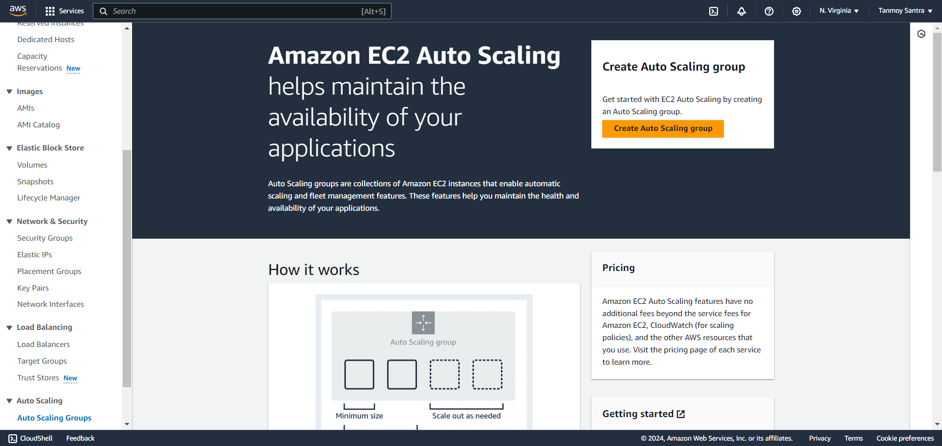

STEP 10- Give a name and select the newly created Template. Then, click on Next .  
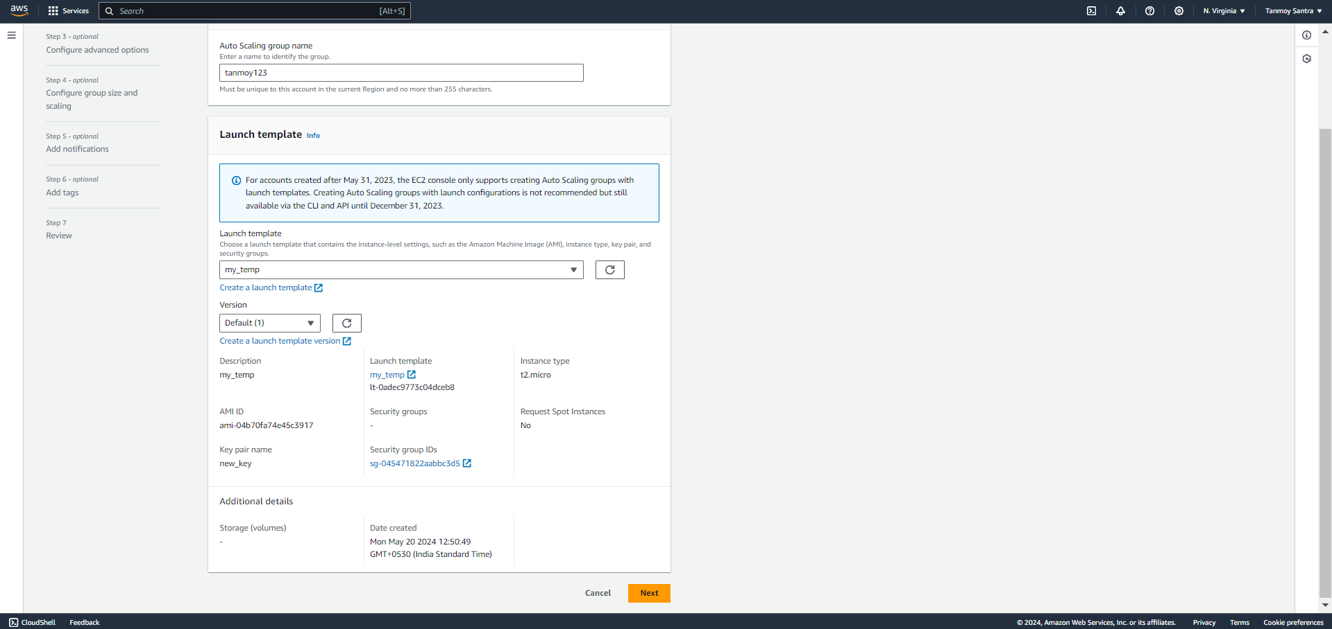  
STEP 11- In Network tab select all the available zones. Then click on next.  
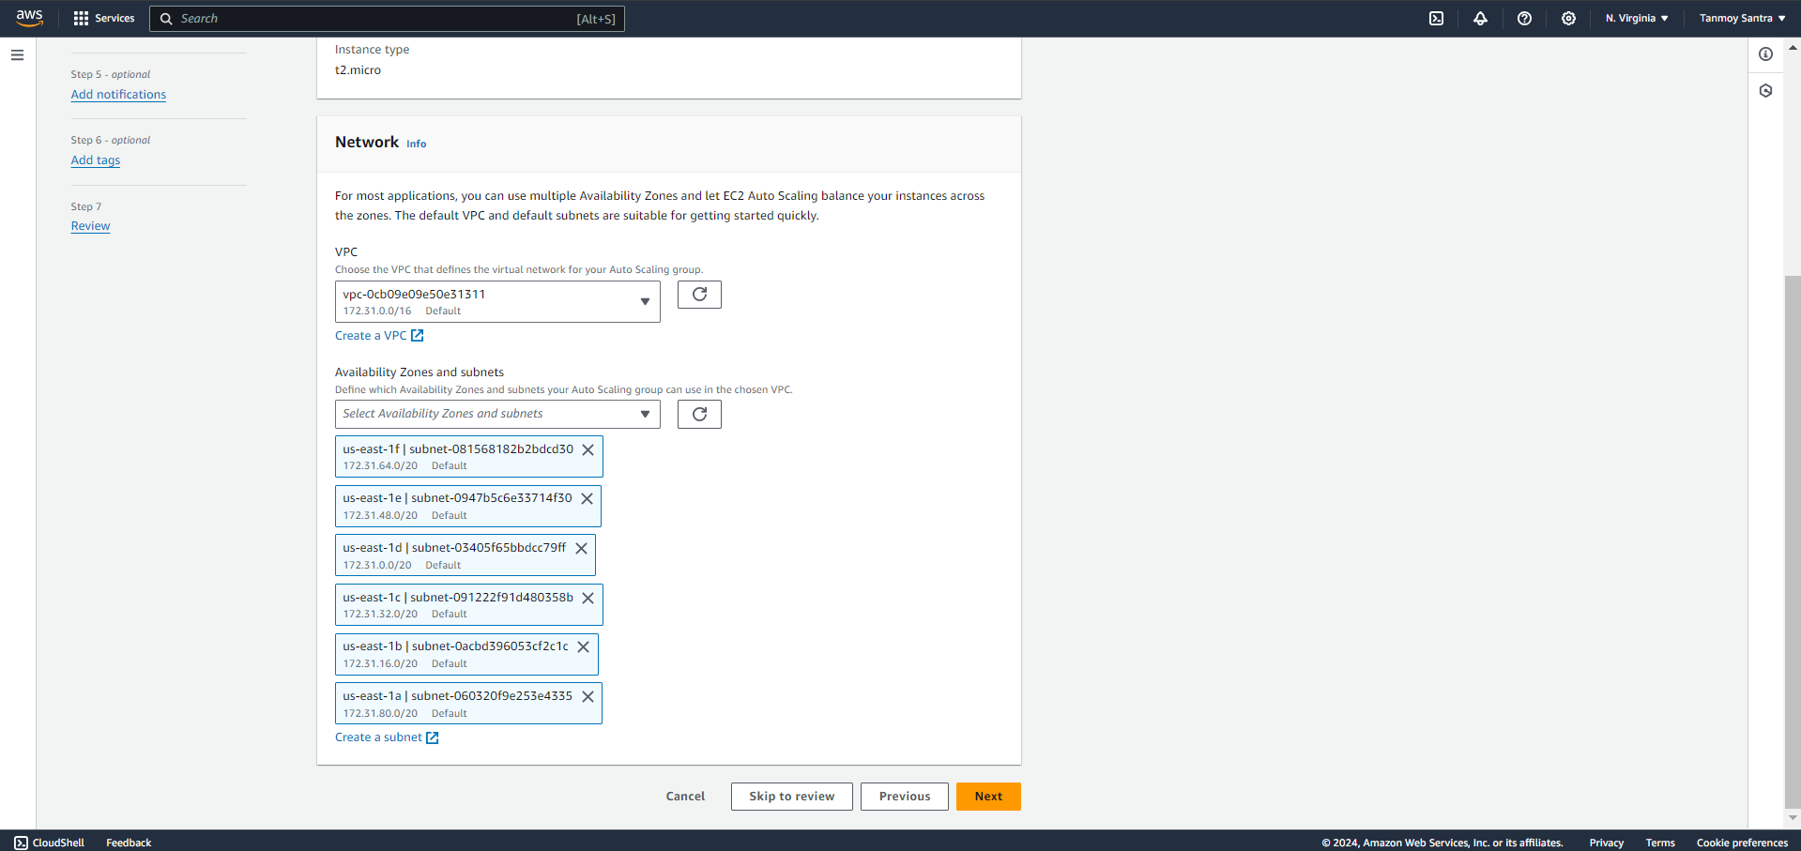  
STEP 12- Select Attach a new load balancer , select Application Load Balancer & select Internet-  
Facing .  
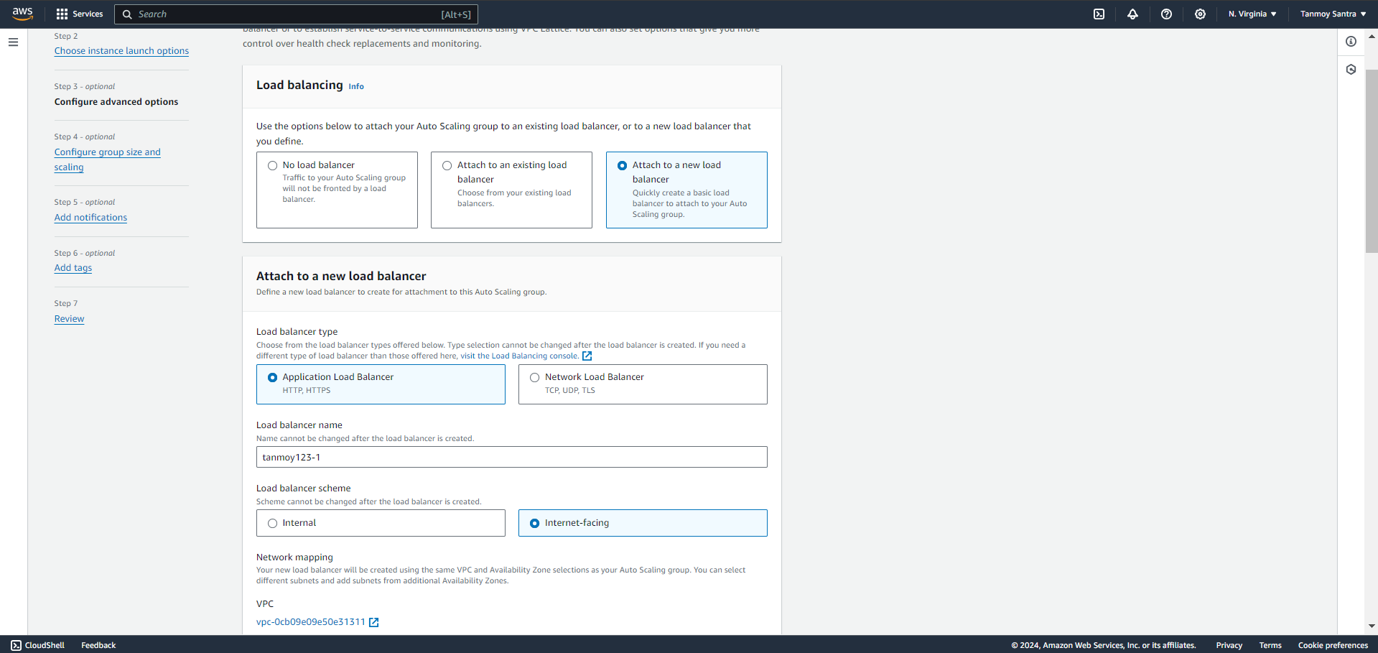

STEP 13- Give the port no. 4000 & select Create a target group. Then select No VPC Lattice Service.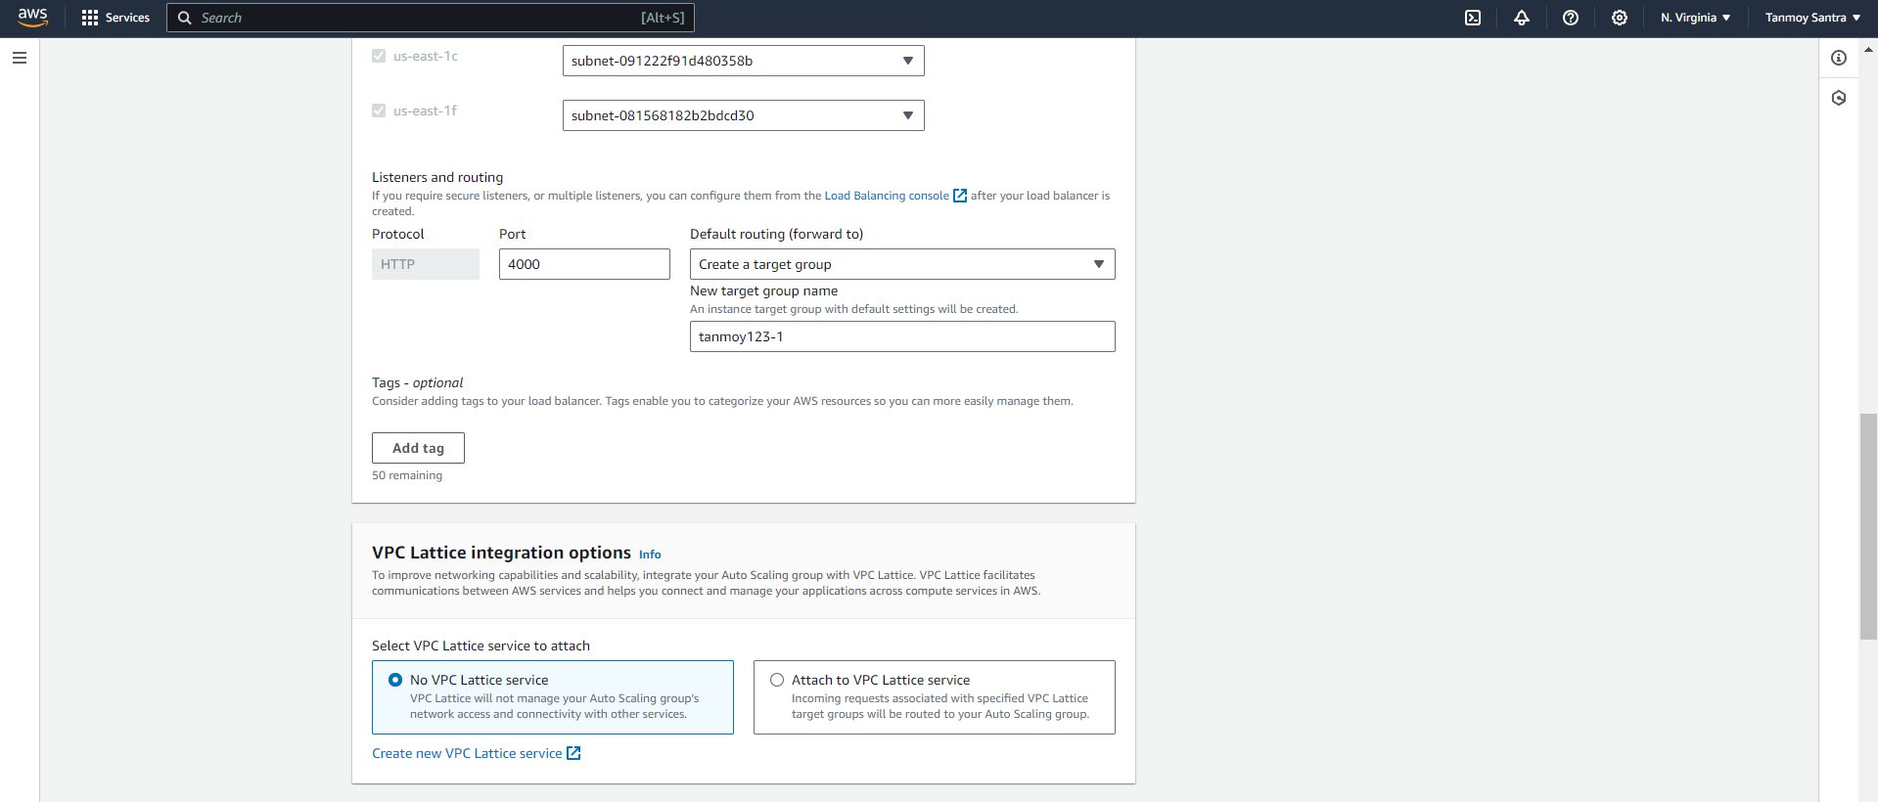STEP 14- Check the Turn on Elastic Load Balancing Health checks checkbox. Give the Health Check  
Grace Period of 240 seconds. Click on NEXT .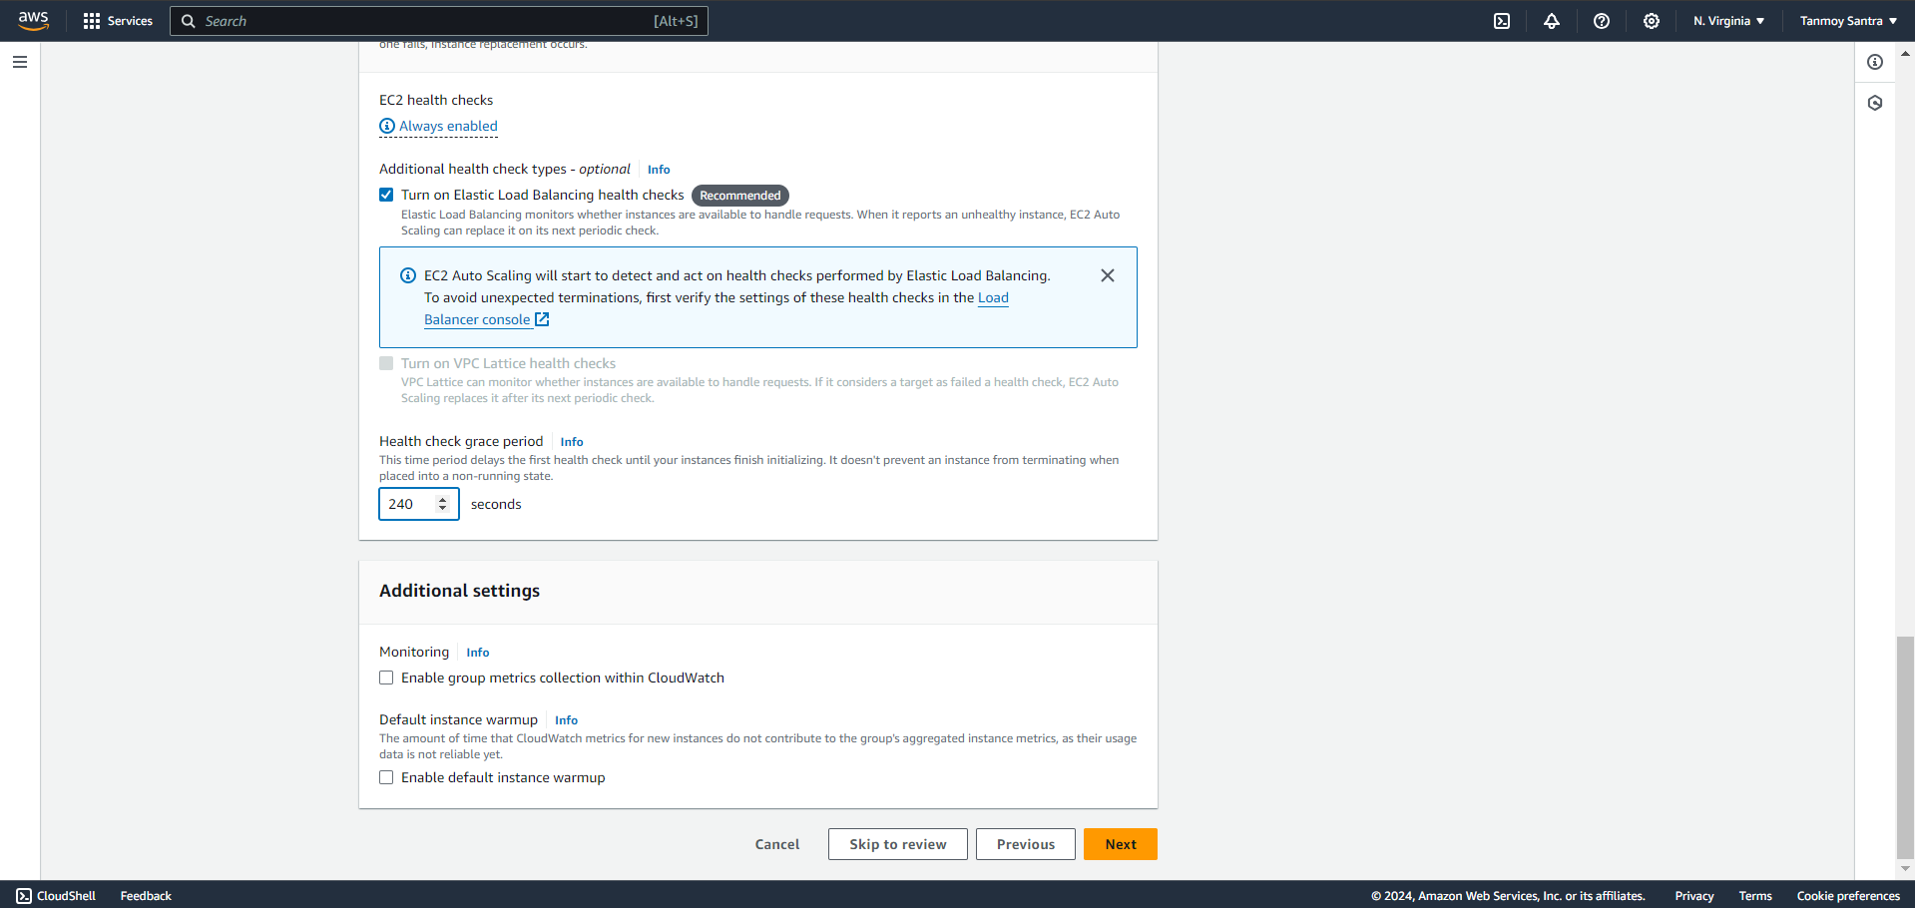STEP 15-Under Desired capacity, give a size of 2.Under Scaling, give min capacity 2 & max capacity 3.  
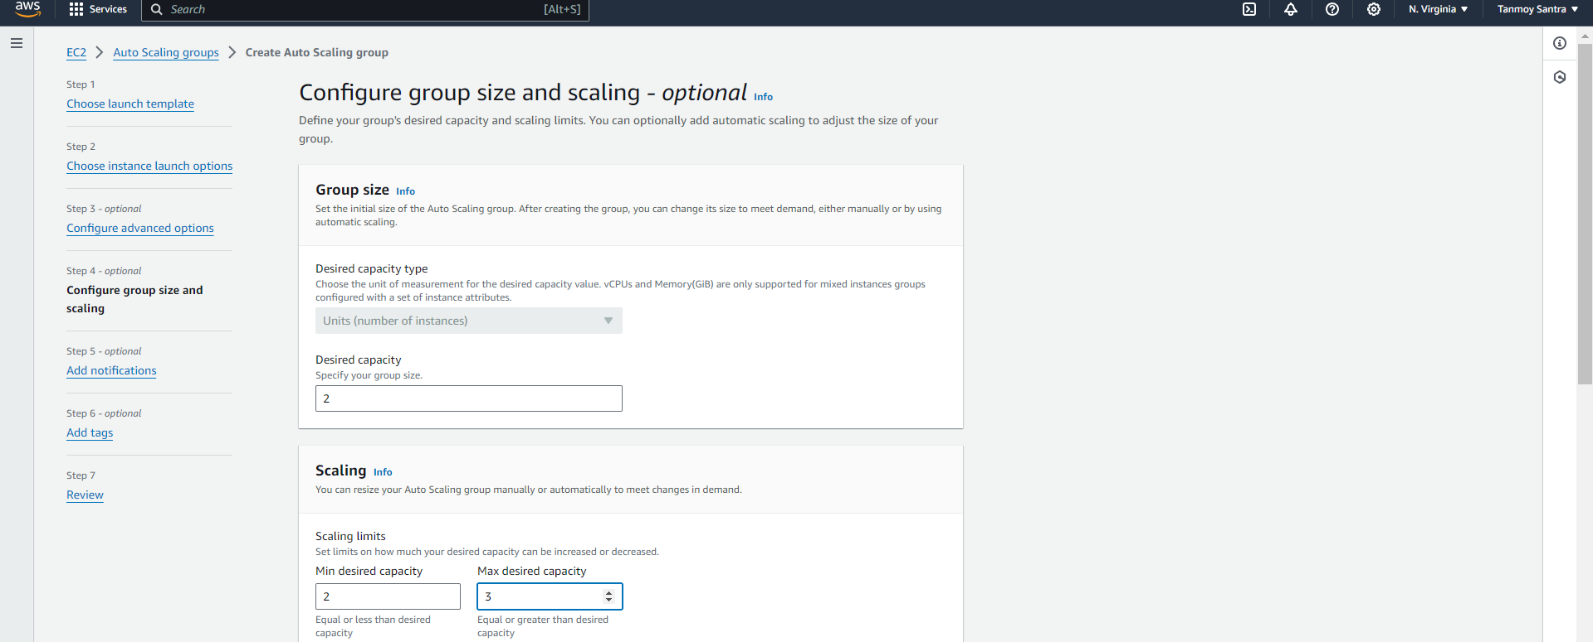

STEP 16-Select Target tracking scaling policy . And give the instance warmup time of 240 seconds.  
Then click on Next .  
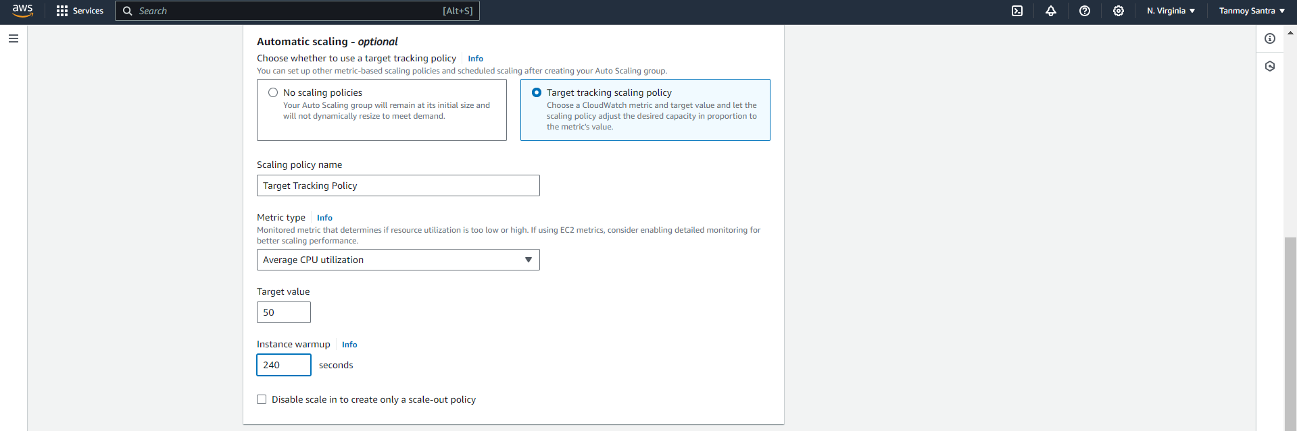  
STEP 17- Click on Next .  
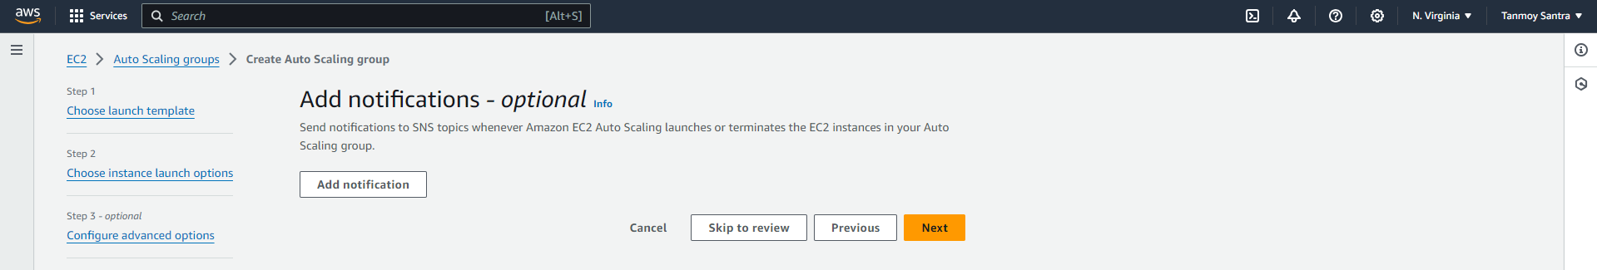

STEP 18- Click on Next .

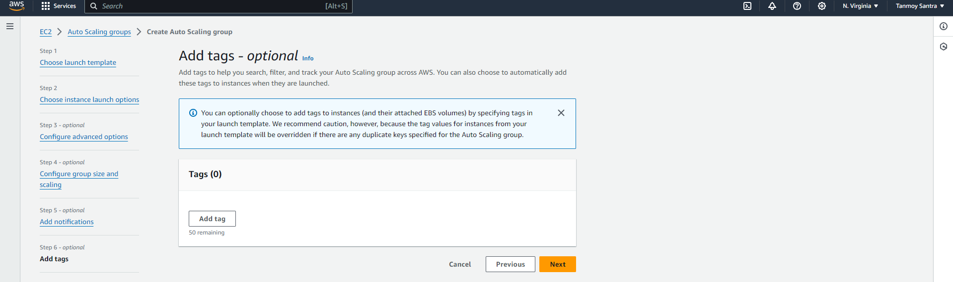

STEP 19- Review all the data of the group to be created and click on Create Auto Scaling Group .

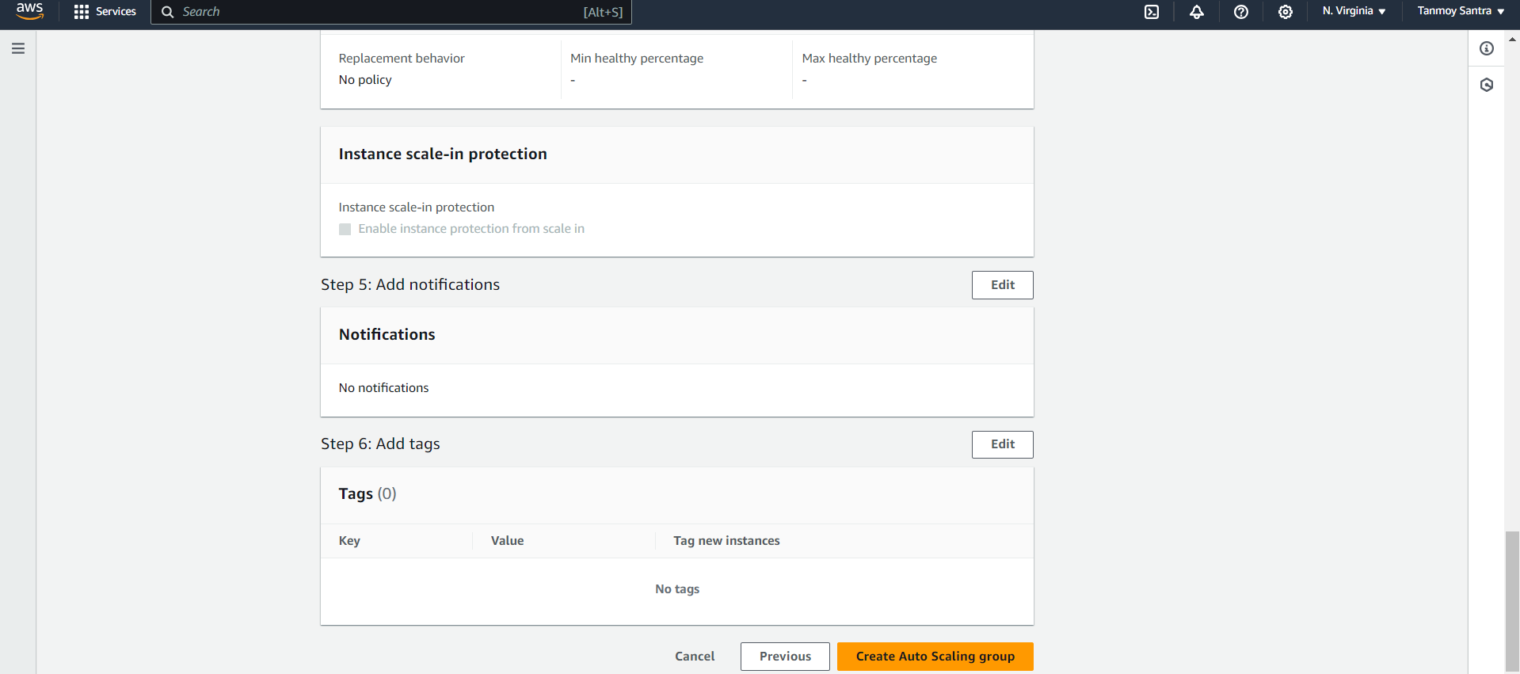

STEP 20- After creating the scaling group, go back to Instances from the left side menu.

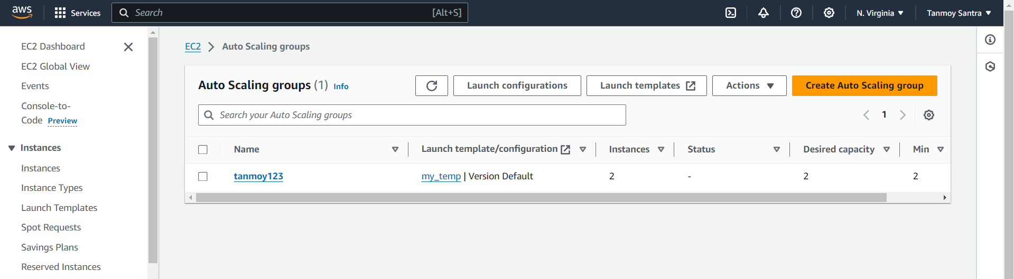

STEP 21- Since the capacity was given as 2, two instances are created. Now open any one of the the  
instance by clicking on its id.  
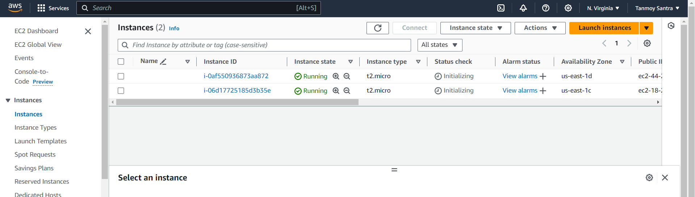

STEP 22- Copy its Public IPv4 Address.

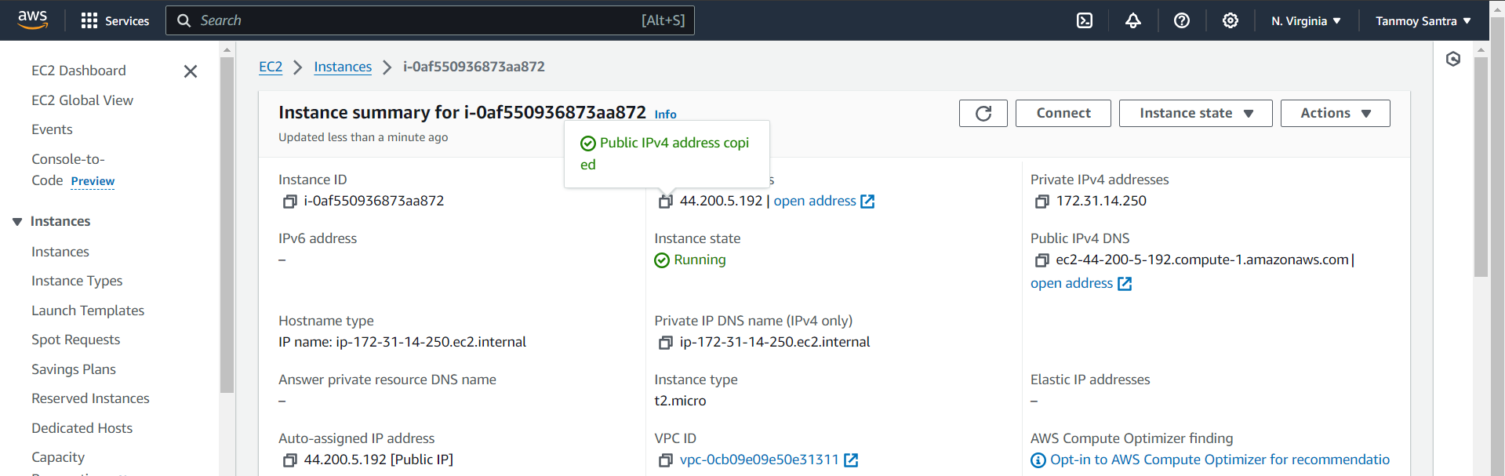

STEP 23- Paste the copied address and click on Log in .

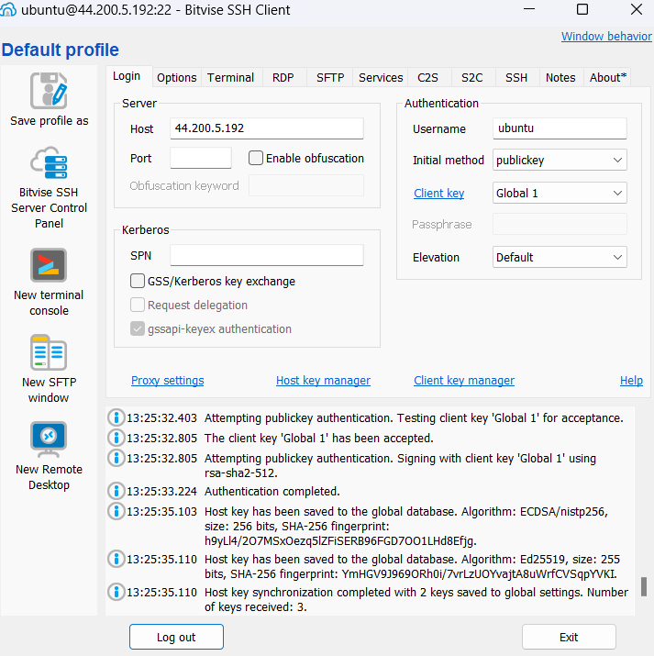

STEP 24- Click on New Terminal Console .  
STEP 25- Type the command:



STEP 26- Write the following code for an infinite loop in the infy.sh file.

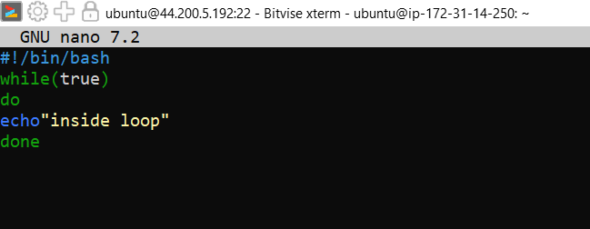

STEP 27- Write the following commands in the terminal:



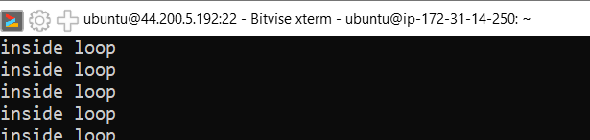

STEP 28- Select both the instances, then under monitoring go to CPU utilization and enlarge it.

STEP 29- The graph shows the CPU Utilization for both the instances.

When the CPU utilization exceed the limit for both the instances, a new instance will be created.

